Application Load Balancer with ORM Stack

Contents

1.Introduction 3
2. Workflow diagram to deploy the stack 3
3.Create Stack (App Lb) 4
4.Plan the Job 8
5. Apply the job 9
6.Verify in the Console 10
7. Destroy the job 12

1.Introduction

Load Balancers provide automated traffic distribution from one entry point to multiple servers reachable from virtual cloud network (VCN). They improve resource utilization, facilitate scaling, and help ensure high availability. The Backend Set resource adds a backend set to a load balancer. The Listener resource in Oracle Cloud Infrastructure Load Balancer service adds a listener to a load balancer.

Pre-request:

1. Compartment OCID to deploy Public Network Load Balancer
2. Region where the Network Load Balancer is deployed
3. Public subnet OCID to deploy Public Network Load Balancer

2. Workflow diagram to deploy the stack
Below diagram shows how the Terraform Artifact are applied inthe OCI. While creating a ORM stack, using terraform deliverables Init, Plan and Apply is the flow to provision the resource in theOCI. We can have the deliverables in any of below.
¬GitLab/GitHub Repo
¬Bitbucket
¬Can be in folder/.zip in the local disk
¬Object Storage Bucket
¬Can be in compartment
¬Oracle provided Template

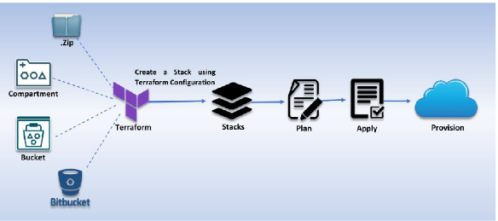

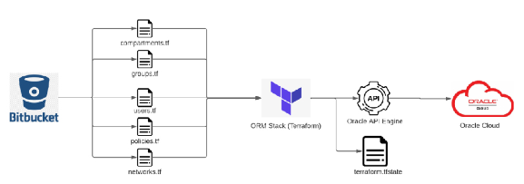

3.Create Stack (App Lb)

Go to OCI Console Developer Services Resource Manager Stacks select the compartment Create Stack
My Configuration Folder Browse

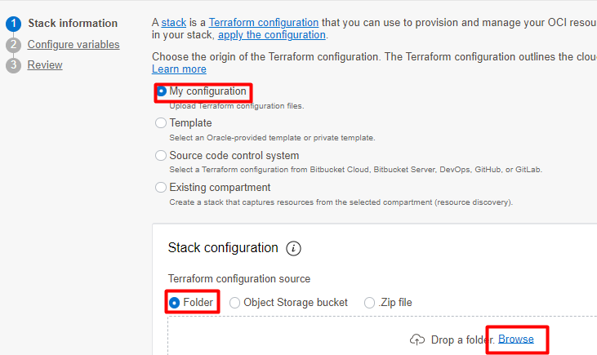

Select the “Application_LoadBalancer ”alb” folder that contains the terraform and yaml Upload

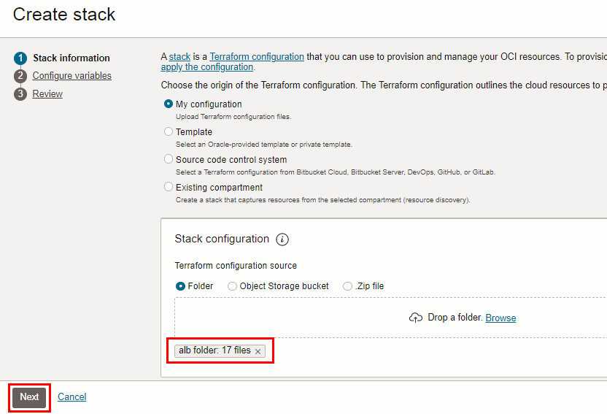

Click “NEXT”

Select the parameters as per the below screen,

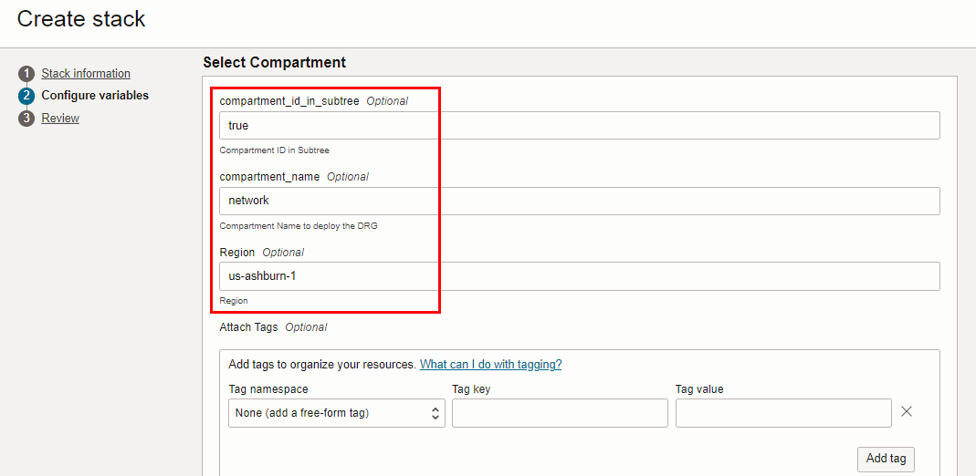
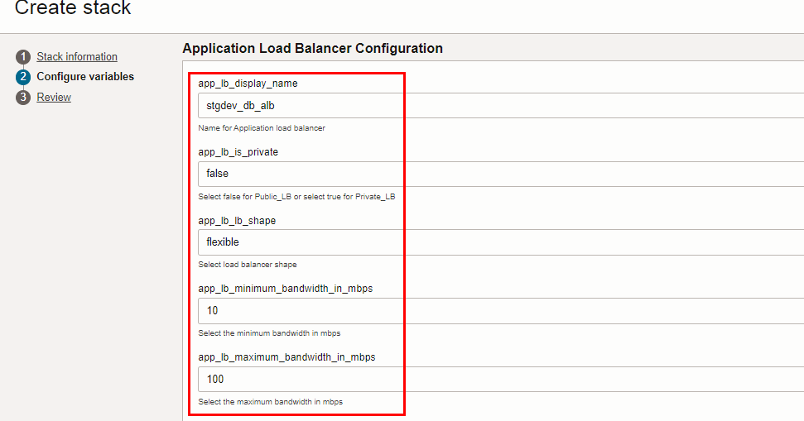
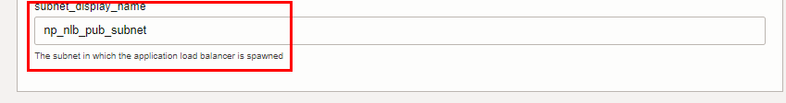
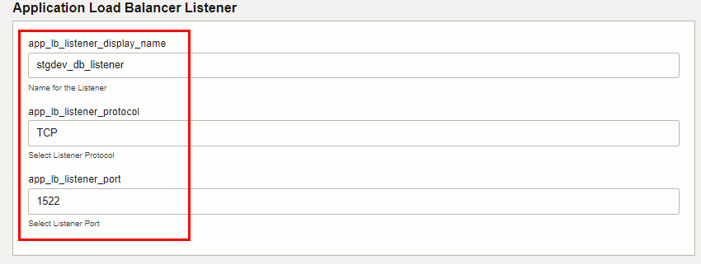
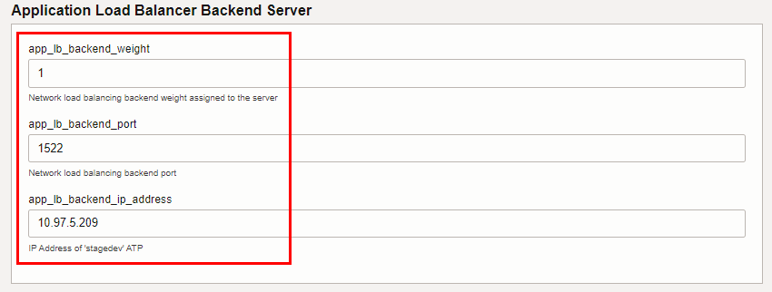
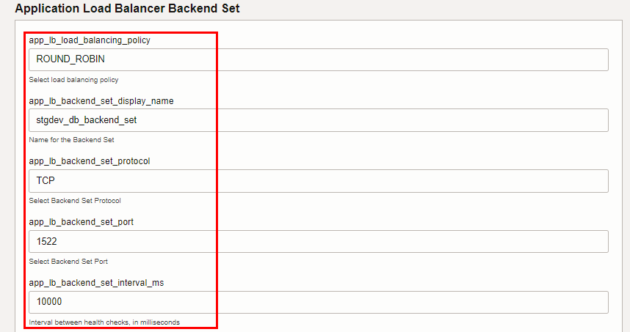
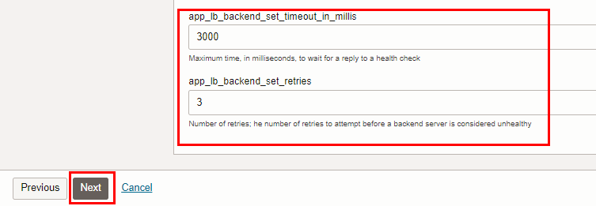

Click “NEXT” Click “CREATE”
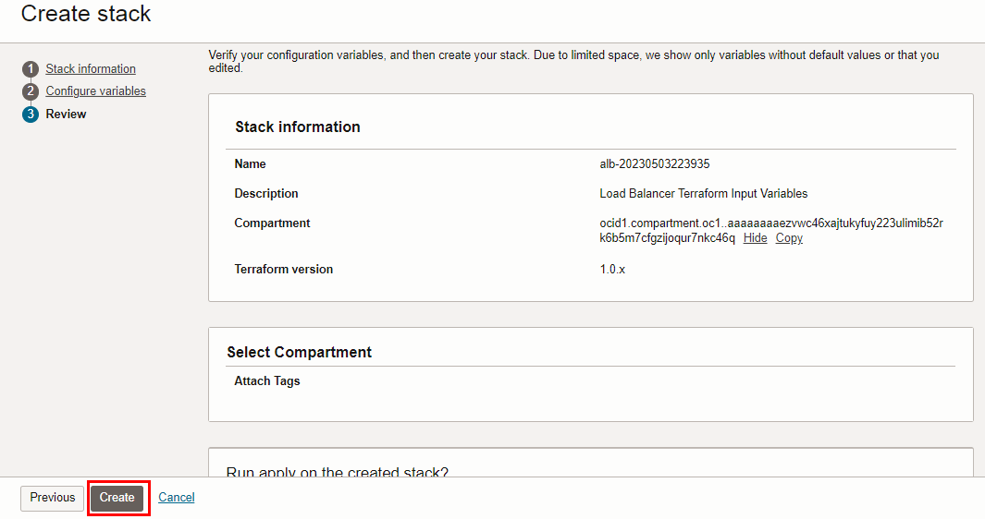

4.Plan the Job

Click the “Plan”
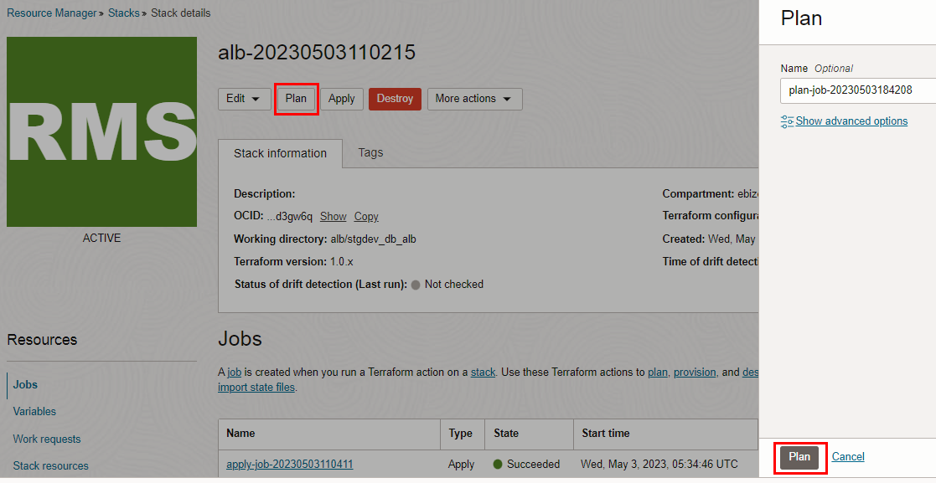

Verify the Plan is successful.

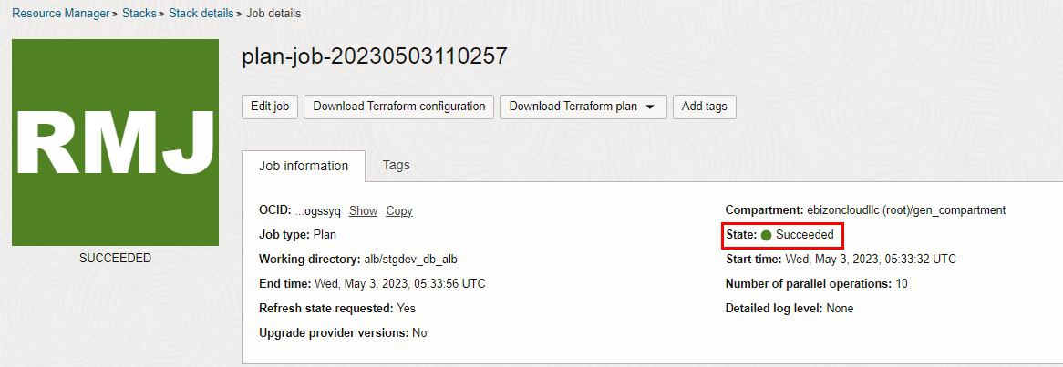
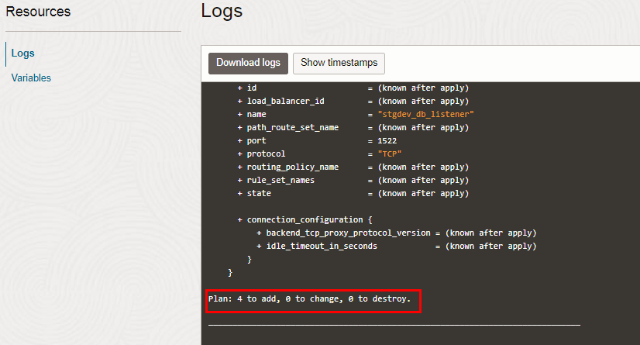

5. Apply the job

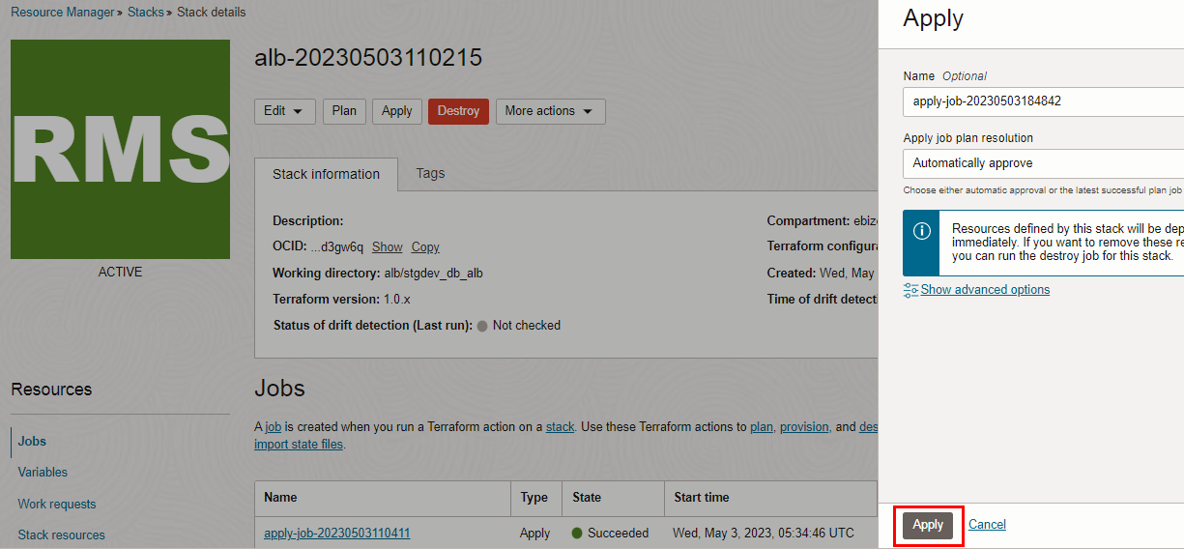

Verify the Apply is successful.

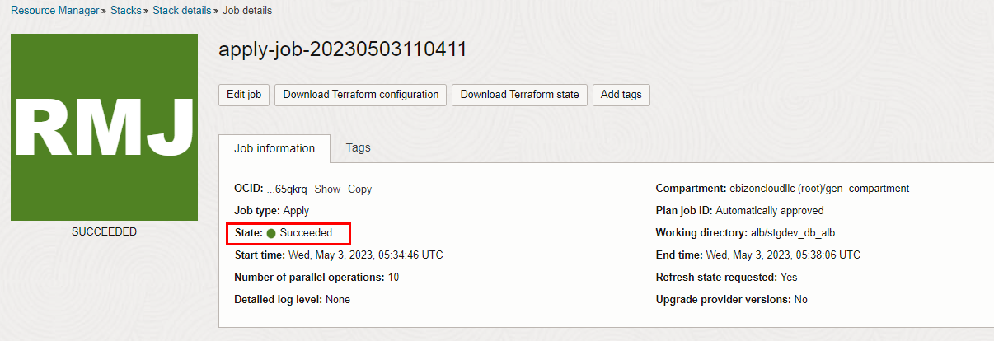
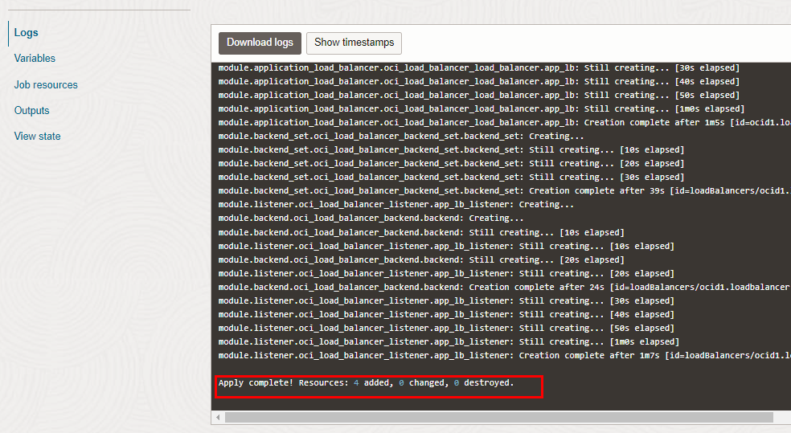

6.Verify in the Console

Go to OCI Console Networking Load Balancers

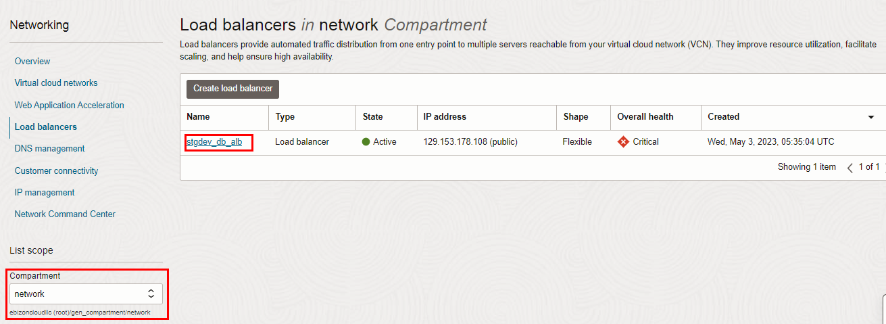
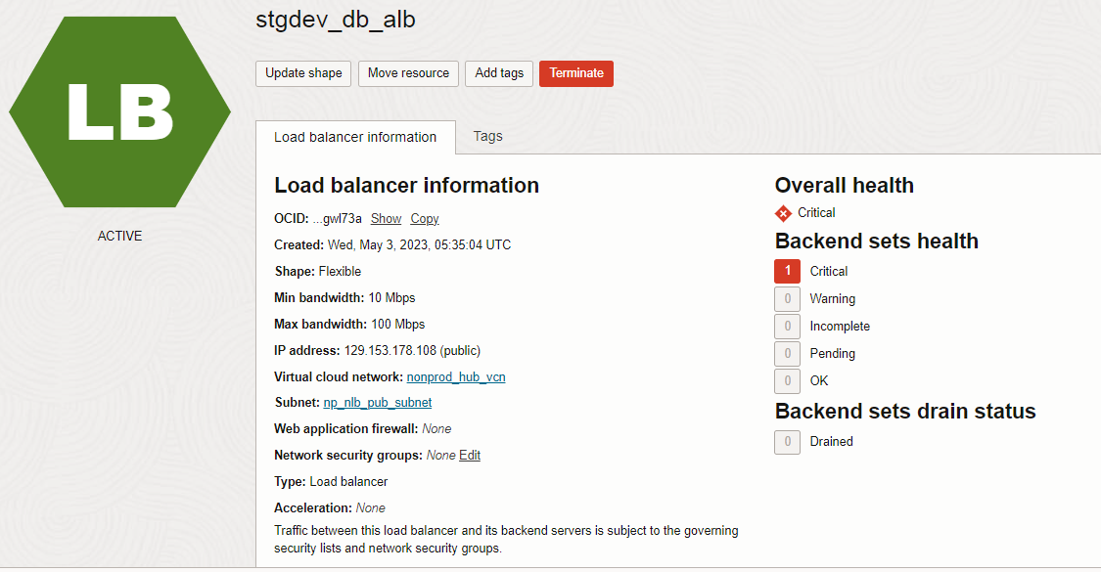
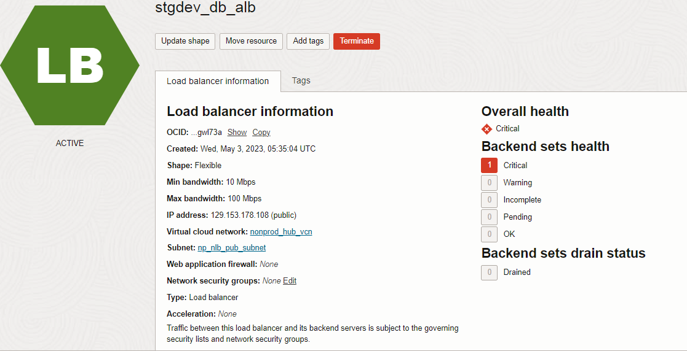
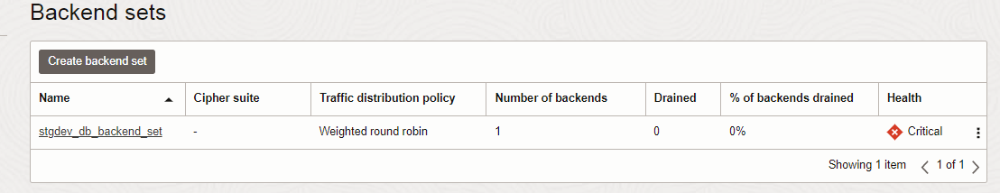
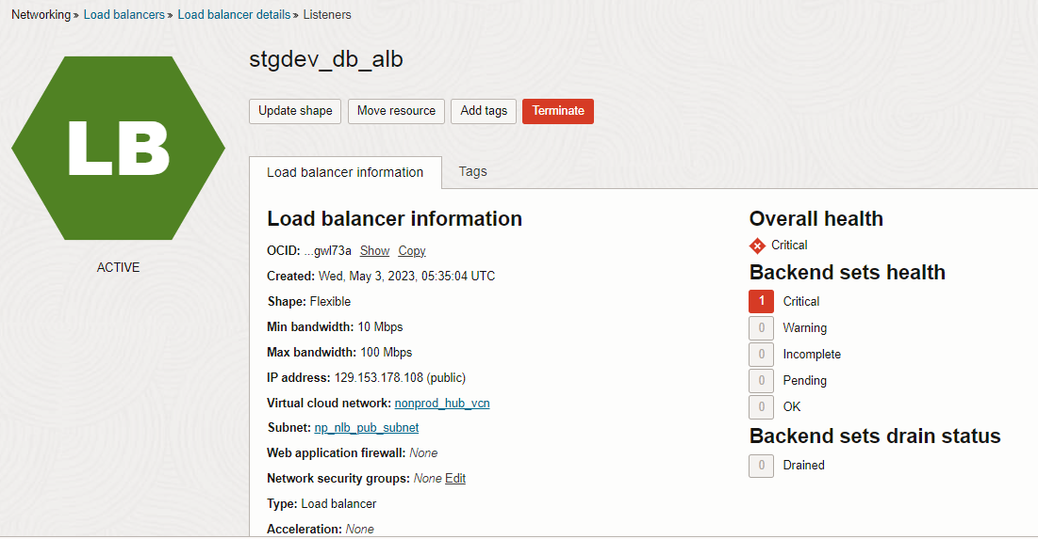
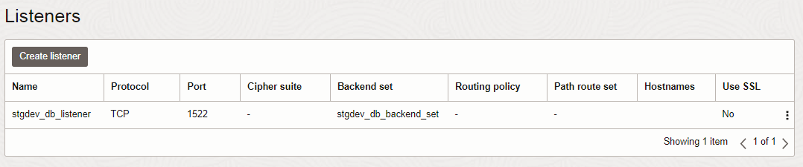

7. Destroy the job

